Fall 2018 Meeting 3- December 5, 2018
Teaching With Technology Faculty Interest Group
Tools to create engaging materials
- Toondoo at www.toondoo.com
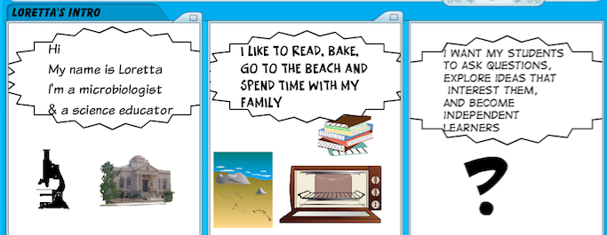

Adobe Spark
- Create your own account (its free). You can easily create web pag3es, graphics and videos

Online Reading tips
http://www.lethbridgecollege.net/elearningcafe/index.php/online-reading-tips-script

What’s next
- Working sessions to create course materials?
- Read a book together-
iGen: Why Today's Super-Connected Kids Are Growing Up Less Rebellious, More Tolerant, Less Happy--and Completely Unprepared for Adulthood--and What That Means for the Rest of Us by Jean M. Twenge
- Gather data across classes
- Your ideas?

